**Cartem’s Donuts Franchise Opportunities**

Kristina Perit

December 29, 2019.

1. **Introduction**
   1. Background

The Canadian gold standard for donuts, Tim Hortons, is experiencing what the Financial Post calls “sluggish sales” [1]. Part of the problem is their adoption of the “lowest common denominator” of food quality, according to Robert Levy, president at BrandSpark International, a research and consulting firm[2]. Recent attempts to innovate the brand have fallen flat as the brand has begun to phase out their Beyond Meat offerings, having failed to attract a younger client base.

Current Canadian opinion of the brand has suffered since their sale to Restaurant Brands International in 2014 including the following tweets about the product quality:



As well as disappointment that another once-Canadian business has been sold to international interests (similar to the sale of Molson Brewing or Hudson’s Bay Company). As such there is a growing opportunity for a Canadian purveyor of quality donuts and coffee to step up and fill Tim Hortons’ shoes, particularly with millenials and Generation Z.

Cartem’s Donuts[3] is a beloved Vancouver donut chain with three locations in neighbourhoods in Vancouver (Downtown, Kitsilano, and Mt. Pleasant). They specialize in donuts handmade with local ingredients by a skilled team of pastry chefs. Their menu includes fried, baked, gluten-friendly[4], and vegan donuts. They have a standard menu[5] but also create special seasonal offerings (such as the delightful Gingerbread, Holiday Nog, and Millionaire’s Shortbread for the holiday season). Also on offer in the shop are pints from Earnest Ice Cream (another Vancouver company) as well as artisanal coffee and tea beverages. They pride themselves on using only fresh, natural ingredients and never stooping to use premixes, preservatives, or freezing. Their motto is “Smiles, Conversations, and Donuts”. With three successful locations (all of which frequently sell out of donuts before day’s end) they are a company on the rise.

* 1. Opportunity

There is an opportunity for Cartem’s to expand to Toronto to fill the need for quality, vegan, and gluten-friendly donuts. The combination of a beloved Canadian company with fresh, local, natural product made with the highest standards will appeal to Millennials particularly as members of this generational group have come of age and become hugely economically influential.

A prime market for initial expansion is Toronto, given the population density, diversity, and workforce. While the downtown core is rife with specialty bakeries there are few in the surrounding areas. As such a focus on multiple stores, with a key flagship location in the core, would take advantage of disgruntled former Tim Hortons’ fans throughout the city. In this report I will identify the prime neighbourhoods for expansion based on population and cafe/bakery availability.

* 1. Interest

While specifically geared to Cartem’s Donuts, this report will also be applicable to any specialty cafe/coffee/bakery hoping to fill the growing void in Toronto’s market, particularly in less serviced areas north of the Toronto downtown core.

1. **Data**

To address the question of expansion locations I utilized the following data sources:

* Foursquare API was utilized to visualize/gain understanding of donut shops (cafes, bakeries, dessert shops, and coffee shops) in Toronto neighbourhoods
* Population data
  + According to the Pew Research Center, millennials can be defined as anyone born between 1981 and 1996[6]. As of 2016, millenials were 20 to 35 years of age. As of the 2016 Canadian census, there were ~1.26 million Millennials in metropolitan Toronto[7].
  + Population data by neighbourhood was acquired from the 2016 Canadian Census via the City of Toronto’s Open Door Portal[8].
  + Toronto neighbourhood data[9],[10],[11].
  + Subway station data[12].

1. **Methods**

As mentioned in the previous sections, the target demographic for a Cartem’s expansion is millenials, as previous research has indicated that they are dissatisfied with Tim Hortons, are financially viable, and have an interest in natural, gluten-friendly, and vegan products that are Canadian. As such I analyzed population data from the 2016 Canadian census to determine which Toronto neighbourhoods have the highest populations of millennials in order to maximize the target demographic in neighbourhoods targeted for expansion. I also included subway station data since neighbourhoods with a subway station are more accessible to millennial populations who commute into Toronto.

As such the initial model predicts appropriate locations for Cartem’s franchises based on:

* Presence of gluten-free and/or vegan cafes
* Millennial population
* Subway station location

Since data regarding the success of previous cafe/donut shops in Toronto is proprietary to each company, there is not yet data by which to train or evaluate the model I built. Once the new franchise locations are finished and open for business sales data can be collected in order to improve the model and determine if there are other influential variables to be included. The model will then be evaluated using machine learning methodologies (including KNN, decision trees, SVM, and logistic regression) to build the best model possible.

1. **Results**
   1. Neighbourhoods:

In total, 103 Toronto neighbourhoods were defined and mapped as follows:

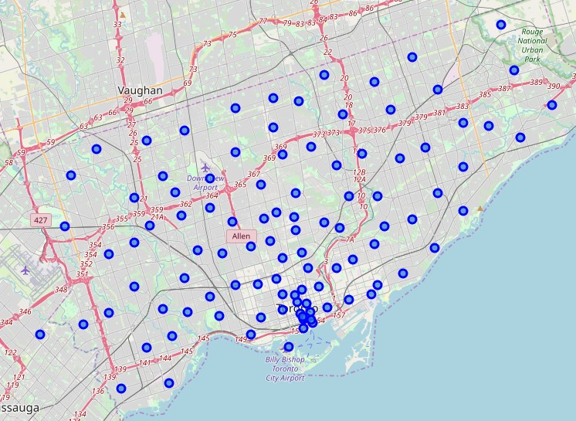

* 1. Gluten Free and Vegan Options:

According to FourSquare 23 Bakeries, Cafes, Coffee Shops, or Dessert Shops were listed as Vegan in 15 different Toronto Neighbourhoods. 18 venues were listed as Gluten Free in 11 different Toronto Neighbourhoods. These venues tended to cluster around the downtown Toronto core as seen in the following map:

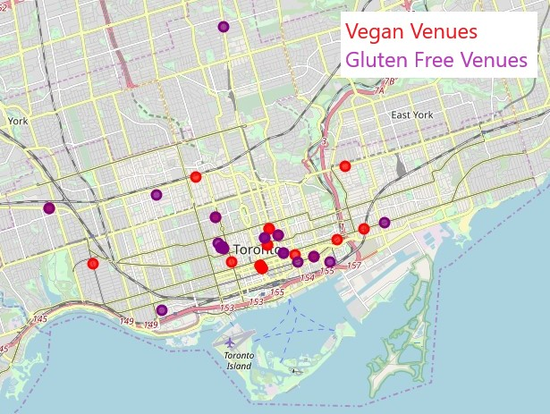

* 1. Millenial Population:

The neighbourhoods with the highest population of Millennials are listed in the table below according to Postal Code and Neighbourhood. Also included in the table are whether neighbourhoods have Gluten Free and/or Vegan venues and a Subway Station.

|  |  |  |  |  |  |
| --- | --- | --- | --- | --- | --- |
| **Postal Code** | **Neighborhood** | **Millenial Population** | **Gluten Free** | **Vegan** | **Subway Station** |
| M1G | Woburn | 12075 | N | N | Y |
| M1H | Cedarbrae | 12075 | N | N | Y |
| M2M | Newtonbrook, Willowdale | 15365 | N | N | Y |
| M4Y | Church and Wellesley | 14045 | N | N | Y |
| M5B | Ryerson, Garden District | 14045 | Y | Y | Y |
| M5C | St. James Town | 14045 | Y | Y | Y |
| M5J | Harbourfront East, Toronto Islands, Union Station | 34850 | N | N | Y |
| M5S | Harbord, University of Toronto | 13385 | Y | Y | Y |
| M5V | CN Tower, Bathurst Quay, Island airport, Harbo... | 34850 | N | N | Y |
| M6G | Christie | 11235 | Y | N | Y |
| M6H | Dovercourt Village, Dufferin | 11235 | N | N | Y |
| M6K | Brockton, Exhibition Place, Parkdale Village | 15690 | Y | N | N |

1. **Discussion:**

As such in order to best capture the Millenial market the following neighbourhoods are recommended for Cartem’s donuts franchises:

|  |  |  |  |  |  |
| --- | --- | --- | --- | --- | --- |
| **Postal Code** | **Neighborhood** | **Millenial Population** | **Gluten Free** | **Vegan** | **Subway Station** |
| M1G | Woburn | 12075 | N | N | Y |
| M1H | Cedarbrae | 12075 | N | N | Y |
| M2M | Newtonbrook, Willowdale | 15365 | N | N | Y |
| M4Y | Church and Wellesley | 14045 | N | N | Y |
| M5B | Ryerson, Garden District | 14045 | Y | Y | Y |
| M5C | St. James Town | 14045 | Y | Y | Y |
| M5J | Harbourfront East, Toronto Islands, Union Station | 34850 | N | N | Y |
| M5S | Harbord, University of Toronto | 13385 | Y | Y | Y |
| M5V | CN Tower, Bathurst Quay, Island airport, Harbo... | 34850 | N | N | Y |
| M6G | Christie | 11235 | Y | N | Y |
| M6H | Dovercourt Village, Dufferin | 11235 | N | N | Y |
| M6K | Brockton, Exhibition Place, Parkdale Village | 15690 | Y | N | N |

These neighbourhoods have the highest population of Millennials, have increased accessibility from the presence of Subway Stations, and do not currently have their Gluten Free and Vegan opportunities met. Here is a map of the neighbourhoods where new Cartem’s Donuts locations are recommended:

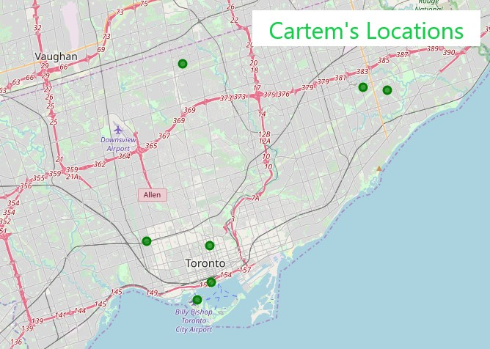

1. **Conclusions**

Cartem’s Donuts has a unique opportunity to profit from Tim Horton’s fall. A beloved Vancouver chain, Cartem’s Donuts’ focus on quality donuts handmade from fresh, natural ingredients, including their gluten friendly and vegan offerings, can take advantage of the Millennial market that Tim Horton’s has failed to attract. Toronto is a prime market for Cartem’s Donuts to expand into because of its large Millennial population (~1.26 million as of 2016). As such, I recommend that Cartem’s Donuts open franchises in the following Toronto neighbourhoods, all of which have a large population of Millennials, lack gluten free and vegan options, and are accessible by Subway: Woburn, Cedarbrae, Newtonbrook/Willowdale, Church and Wellesley, Harbourfront East/Toronto Islands/Union Station, CN Tower/Bathurst Quay/Island Airport, and Dovercourt Village/Dufferin. Once locations are open and generating sales this model can be revisited to determine whether it is accurate and where Cartem’s Donuts (or another beloved Canadian chain) can expand to next.

1. <https://business.financialpost.com/news/retail-marketing/update-1-restaurant-brands-sales-miss-estimates-as-tim-hortons-disappoints>
2. <https://www.bnnbloomberg.ca/choice-of-last-resort-why-tim-hortons-sales-are-lagging-and-what-it-can-do-to-change-that-1.1341469>
3. https://www.cartems.com
4. However they cannot currently guarantee that their donuts are gluten free and should not be consumed by those with severe allergies to gluten.
5. <https://www.cartems.com/menu/>
6. <https://www.pewresearch.org/fact-tank/2019/01/17/where-millennials-end-and-generation-z-begins/>
7. <https://www12.statcan.gc.ca/census-recensement/2016/dp-pd/prof/details/page.cfm?Lang=E&Geo1=CMACA&Code1=535&Geo2=PR&Code2=35&Data=Count&SearchText=Caledon%20East&SearchType=Begins&SearchPR=01&B1=All>
8. <https://open.toronto.ca/dataset/neighbourhood-profiles/>
9. <https://en.wikipedia.org/wiki/List_of_postal_codes_of_Canada:_M>
10. <http://cocl.us/Geospatial_data>
11. <https://www.toronto.ca/city-government/data-research-maps/neighbourhoods-communities/neighbourhood-profiles/>
12. <https://www.google.com/search?q=subway+stations+toronto&npsic=0&rflfq=1&rlha=0&rllag=43712413,-79447568,8786&tbm=lcl&ved=2ahUKEwit4dr1xPzmAhVCd6wKHTCvD4IQtgN6BAgKEAQ&tbs=lrf:!3sIAE,lf:1,lf_ui:3&rldoc=1>